With backlighting:
X-Keys® XK-24 Programmable Keypad

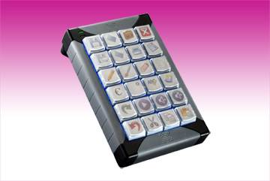
Germering, July, 11th 2012. www.tastaturen.com presents the XK-24, a programmable keypad with 24 relegendable keys. A new feature is the blue or red backlighting adressable for each key. The new XK-24 with MacroWorks 3 software combines the tradition of rugged, reliable X-keys with added features for the same price as the X-keys Desktop. With four more keys in a smaller footprint, the XK-24 sports a new co-injected case suitable for handheld applications. Clear key lenses keep your printed or hand written legends securely in place and protect them from wear while making it quick and easy to update them. The full travel keys have the same feel as your standard keyboard. A wide variety of key caps and key blockers make it easy to customize the XK-24 into a simple control surface like a bump bar or a live audio switcher.
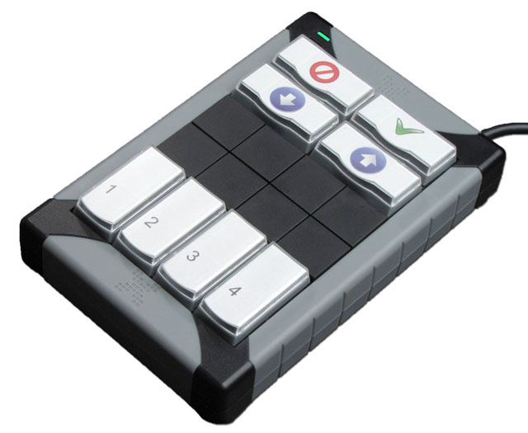
Price and Availability
The price is on demand, the keypad is on stock. More information:
http://www.tastaturen.com/x-key-24

About GeBE
GeBE Computer & Peripherie GmbH was founded in January of 1998. The company develops and manufactures customer specific keyboards, such as foil and short stroke keyboards, as well as protective silicone key linings. GeBE manufactures keyboards but also distributes quality name brand keyboards. Areas of operations are industrial, standard input systems and OEM-Solutions.

GeBE Computer & Peripherie GmbH
Untere Bahnhofstraße 38 A, 82110 Germering
Phone: +49 89 894399-0, Fax: +49 89 894399-11
Email: sales@tastaturen.com
URL: http://www.tastaturen.com

Media contact
Astrid Kornelius
Phone: +49 89 894399-0
Email: ak@tastaturen.com

Customer Contact
Paul Pabst
Tel.: +49 89 894399-0
Email: paul.pabst@tastaturen.com

