On the road:
So Cool in-vehicle keyboard built for mobile data-input

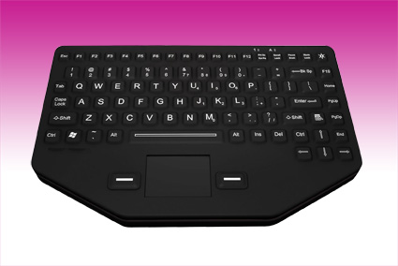
Germering, November 25th 2013.
www.tastaturen.com is introducing the new So Cool silicone keyboard. This in-vehicle keyboard was created with the driver in mind. Typing reports in a parked car while twisting at a 45 degree angle is back breaking, The So Cool is specially designed to be removed from standard mounting clips and fit squarely on the driver’s lap for comfortable and stable typing. Spills won’t bother this rugged silicone keyboard because nothing can get inside, and it’s quite unlike old fashion squad car, ambulance and fire truck keyboards. It comes standard with a red backlight which may be turned on & off and adjusted to exacting comfort with the touch of a single button. The rugged keyboard is waterproof according to DIN IP 67 and comes with USB interface.

Price and Availability:
Please click here for more information:
http://www.tastaturen.com/socool

About GeBE
GeBE Computer & Peripherie GmbH was founded in January of 1998. The company develops and manufactures customer specific keyboards, such as foil and short stroke keyboards, as well as protective silicone key linings. GeBE manufactures keyboards but also distributes quality name brand keyboards. Areas of operations are industrial, standard input systems and OEM-Solutions.

GeBE Computer & Peripherie GmbH
Edelweißstraße 20, 82110 Germering
Tel.: (089) 894399-0, Fax: (089) 894399-11
Email: sales@tastaturen.com
URL: http://www.tastaturen.com

Press Contact
Astrid Kornelius
Tel.: (089) 894399-14
Fax: (089) 894399-11
Email: ak@tastaturen.com

Customer Contact
Paul Pabst
Tel.: (089) 894399-0
Fax: (089) 894399-11
Email: paul.pabst@tastaturen.com

