Experienced:
KVK-84 metal keyboards now with numeric keypad

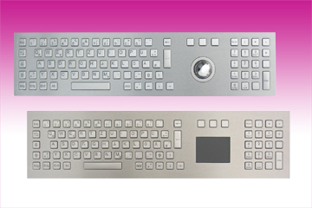
Germering, April 1st, 2014.
www.tastaturen.com is introducing the successor of the popular series KVK-65 keyboard family: Rugged stainless steel keyboards as a front panel version available with either a 38 mm trackball or a touchpad. The new layout has an additional 19-key numeric pad which was attached to the outer right edge.

Ideal for kiosk applications
This promises an experienced data entry, since the arrangement conforms to a standard keyboard layout. Available are these keyboards with the most common basic country layouts. Customer-specific adaptations are possible due to the flexible laser marking of the keys. A separate numeric keypad is also available, this can be realized with USB, PS2 or matrix interface. The KVK-84 front panels have a total of 84 input keys and are particularly suitable for kiosk systems and POS applications. With USB port.

Price and Availability
Please click here for more information:
http://www.tastaturen.com/kvk-84touch

About GeBE
GeBE Computer & Peripherie GmbH was founded in January of 1998. The company develops and manufactures customer specific keyboards, such as foil and short stroke keyboards, as well as protective silicone key linings. GeBE manufactures keyboards but also distributes quality name brand keyboards. Areas of operations are industrial, standard input systems and OEM-Solutions.

GeBE Computer & Peripherie GmbH
Edelweißstraße 20, 82110 Germering
Tel.: (089) 894399-0, Fax: (089) 894399-11
Email: sales@tastaturen.com
URL: http://www.tastaturen.com

Press Contact
Astrid Kornelius
Tel.: (089) 894399-14
Fax: (089) 894399-11
Email: ak@tastaturen.com

Customer Contact
Paul Pabst
Tel.: (089) 894399-0
Fax: (089) 894399-11
Email: paul.pabst@tastaturen.com

