Lock thing:
KSS-19 Keyboard Drawer with Stainless Steel Front

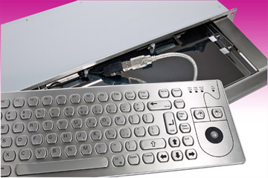
Germering, May 5th, 2014.
www.tastaturen.com is introducing the KSS-19 keyboard drawer, now new with a stainless steel front aperture (formerly aluminium). The retractable 19'' keyboard drawer 1 HE is specially designed for 19'' rack mount systems and for control consoles with an installation depth of at least 150 mm. The drawer is ideal for standard keyboards. The KVS-91 stainless steel keyboard fits perfectly into the drawer and can be ordered in addition. The drawer has a protection degree of DIN IP65, whether open or closed. It comes with USB or PS2 interface.

The integrated stainless steel keyboard has a compact layout and provides a pleasant tactile feedback. It is equipped with an optical 13-mm trackball or optionally available with a finger mouse in the form of 4 keys. Ideal for areas with a high degree of pollution e.g. in the manufacturing sector. But even in medical fields, like in pure or laboratory rooms, it is very popular.

Price and Availability
Please click here for more information:
http://www.tastaturen.com/kss-19

About GeBE
GeBE Computer & Peripherie GmbH was founded in January of 1998. The company develops and manufactures customer specific keyboards, such as foil and short stroke keyboards, as well as protective silicone key linings. GeBE manufactures keyboards but also distributes quality name brand keyboards. Areas of operations are industrial, standard input systems and OEM-Solutions.

GeBE Computer & Peripherie GmbH
Edelweißstraße 20, 82110 Germering
Tel.: (089) 894399-0, Fax: (089) 894399-11
Email: sales@tastaturen.com
URL: http://www.tastaturen.com

Press Contact
Astrid Kornelius
Tel.: (089) 894399-14
Fax: (089) 894399-11
Email: ak@tastaturen.com

Customer Contact
Paul Pabst
Tel.: (089) 894399-0
Fax: (089) 894399-11
Email: paul.pabst@tastaturen.com

