Industry compliant:
KSS-19 keyboard drawer (1U) with durable stainless steel bezel and robust PC keyboard
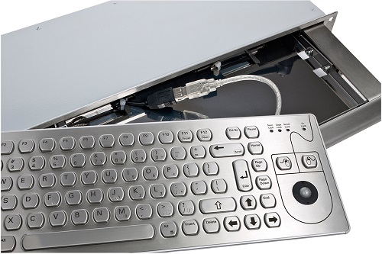
Germering, January 2022. tastaturen.com introduces the KSS-19, a slim stainless steel keyboard drawer equipped with a high-quality stainless steel front panel, replacing the previous aluminum variant. The advantage: Aluminum is lighter, but stainless steel is far more durable and resistant. With only one height unit (1U corresponds to 4.4 cm), it is one of the ultra-slim drawers with a mounting depth of 150 mm for standard 19-inch racks. The matching KVS-91 stainless steel PC keyboard can be ordered as an option. The protection class is DIN IP65 when open and closed. Easy Plug & Play is guaranteed by the USB interface. A PS/2 connection is available on request.
Various mouse options
The built-in stainless steel keypad has a standard MF2 layout with all function and control keys. The jog stop is pleasant with noticeable tactile feedback. The optical 13 mm trackball is also convincing with corresponding industry-compliant robustness. Instead of the trackball, the KVS-91 is also available with a 4-button finger mouse or touchpad. The pair is ideal for areas with a high degree of contamination, such as in the manufacturing industry or in machine and plant construction. Nevertheless, the drawer can also be used very well in medical areas, such as clean rooms or laboratories.

Download: Press Release Download Text and Picture

Contact

GeBE Computer & Peripherie GmbH
Edelweißstraße 20, 82110 Germering
Tel.: (089) 894399-0, Fax: (089) 894399-11
Email: sales@tastaturen.com
URL: http://www.tastaturen.com

Press contact
Astrid Kornelius
Tel.: (089) 894399-0, Fax: (089) 894399-11
Email: marketing@tastaturen.com

Customer contact
Paul Pabst
Tel.: (089) 894399-0, Fax: (089) 894399-11
Email: paul.pabst@tastaturen.com

About tastaturen.com
GeBE Computer & Peripherie GmbH was founded in January 1998. The company develops, produces and distributes customized keyboards, especially membrane and short-stroke keyboards as well as silicone keypads. GeBE is a manufacturer of its own as well as a distributor of multi-vendor, well-known keyboard products.

