Avoides Loopholes:
„Cool LP“ Silicone Keyboard Series for demanding production environments
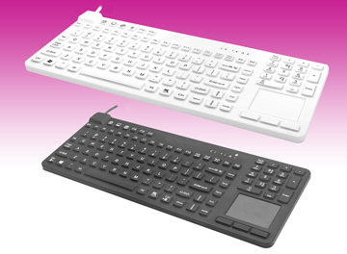

Germering, October 12h, 2015. www.tastaturen.com now presents the silicone keyboards of the new series „Cool LP“ (low profile). The dense keyboards are ideal partners in production environments. The ultra-flat keyboard character avoids loopholes for dirt and dust. The devices are waterproof according to DIN IP 68 and due to this they are very uncomplicated in use and cleaning. The protection degree guarantees a high quality in demanding production environments. With a noticeable keystroke the keyboards offer a very comfortable operation, even with gloves. The „key-clicks“, however, are so quiet that you can barely hear them.
The devices in black or white with USB connection are available with or without integrated touchpad and alternatively in a very compact version without numpad. In German and US-layout on stock.
GeBE Computer & Peripherie GmbH exhibits at the SPS/IPC/Drives in Nuremberg from November 24th to 26th, 2015, in hall 8, stand 400.

Price and Availability
Please click here for more information: http://www.tastaturen.com/coolserie_LP

About GeBE
GeBE Computer & Peripherie GmbH was founded in January of 1998. The company develops and manufactures customer specific keyboards, such as foil and short stroke keyboards, as well as protective silicone key linings. GeBE manufactures keyboards but also distributes quality name brand keyboards. Areas of operations are industrial, standard input systems and OEM-Solutions.

GeBE Computer & Peripherie GmbH
Edelweißstraße 20, 82110 Germering
Tel.: (089) 894399-0, Fax: (089) 894399-11
Email: sales@tastaturen.com
URL: http://www.tastaturen.com

Press Contact
Diana Zimmermann
Tel.: (089) 894399-14
Fax: (089) 894399-11
Email: marketing@tastaturen.com

Customer Contact
Paul Pabst
Tel.: (089) 894399-0
Fax: (089) 894399-11
Email: paul.pabst@tastaturen.com

