Up and down:
TVG-50 now with built-in scroll wheel

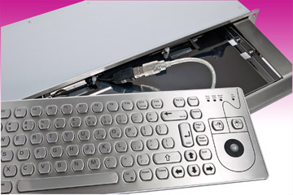
Germering, January 19h, 2015.
www.tastaturen.com introduces a new module from the TVG series. The TVG-50-2-Scroll is a 50 mm optical trackball, which puts together with an additional scroll wheel in a sturdy stainless steel front panel. The scroll wheel is mounted above the ball between the two mouse buttons. This guarantees a faster and targeted data input.

The devices were developed by GeBE and are particularly suitable for outdoor applications that need to withstand a robust input. All components are prudently exactly fitted into the front panel so that the possibility of bursting out is nearly impossible. Through rear studs simple assembly is guaranteed. The front panel has 142x110x30 mm with very small dimensions. The devices are available with a USB port.

Price and Availability
Please click here for more information:
http://www.tastaturen.com/tvg50scroll

About GeBE
GeBE Computer & Peripherie GmbH was founded in January of 1998. The company develops and manufactures customer specific keyboards, such as foil and short stroke keyboards, as well as protective silicone key linings. GeBE manufactures keyboards but also distributes quality name brand keyboards. Areas of operations are industrial, standard input systems and OEM-Solutions.

GeBE Computer & Peripherie GmbH
Edelweißstraße 20, 82110 Germering
Tel.: (089) 894399-0, Fax: (089) 894399-11
Email: sales@tastaturen.com
URL: http://www.tastaturen.com

Press Contact
Astrid Kornelius
Tel.: (089) 894399-14
Fax: (089) 894399-11
Email: ak@tastaturen.com

Customer Contact
Paul Pabst
Tel.: (089) 894399-0
Fax: (089) 894399-11
Email: paul.pabst@tastaturen.com

